TsProject

Suneeth Ravilla

4/29/2020

data <- read.csv("~/Downloads/proj data (1).csv")  
library(aTSA)

##   
## Attaching package: 'aTSA'

## The following object is masked from 'package:graphics':  
##   
## identify

#complete.cases(data)

yeardat = aggregate(Sunspots~Year,data = data,FUN = "sum")

dat1 <- yeardat[c(1:225),]  
dat2 <-yeardat[c(226:235),]

x<-subset(dat1, select = Sunspots)  
x1<-ts(x)  
ts.plot(x1)

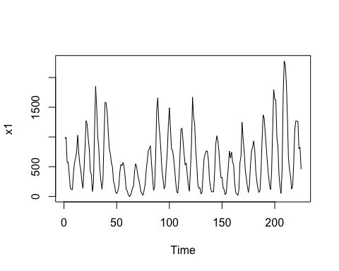

log1<-log(x1)  
ts.plot(log1)

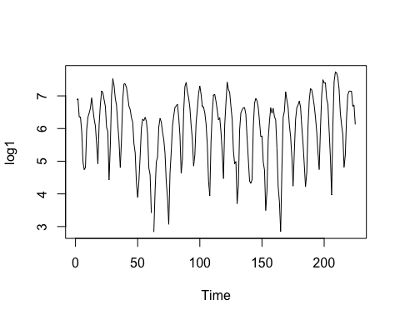

t<-data.matrix(x1[1:200,])  
stationary.test(t)

## Augmented Dickey-Fuller Test   
## alternative: stationary   
##   
## Type 1: no drift no trend   
## lag ADF p.value  
## [1,] 0 -2.35 0.0201  
## [2,] 1 -4.99 0.0100  
## [3,] 2 -3.73 0.0100  
## [4,] 3 -2.90 0.0100  
## [5,] 4 -2.40 0.0180  
## Type 2: with drift no trend   
## lag ADF p.value  
## [1,] 0 -4.22 0.01  
## [2,] 1 -9.89 0.01  
## [3,] 2 -8.69 0.01  
## [4,] 3 -7.26 0.01  
## [5,] 4 -6.82 0.01  
## Type 3: with drift and trend   
## lag ADF p.value  
## [1,] 0 -4.19 0.01  
## [2,] 1 -9.86 0.01  
## [3,] 2 -8.67 0.01  
## [4,] 3 -7.24 0.01  
## [5,] 4 -6.81 0.01  
## ----   
## Note: in fact, p.value = 0.01 means p.value <= 0.01

library(aTSA)  
library(TSA)

##   
## Attaching package: 'TSA'

## The following objects are masked from 'package:stats':  
##   
## acf, arima

## The following object is masked from 'package:utils':  
##   
## tar

library(forecast)

## Warning: package 'forecast' was built under R version 3.6.2

## Registered S3 method overwritten by 'quantmod':  
## method from  
## as.zoo.data.frame zoo

## Registered S3 methods overwritten by 'forecast':  
## method from  
## fitted.Arima TSA   
## plot.Arima TSA

##   
## Attaching package: 'forecast'

## The following object is masked from 'package:aTSA':  
##   
## forecast

auto.arima(x1)

## Series: x1   
## ARIMA(3,0,1) with non-zero mean   
##   
## Coefficients:  
## ar1 ar2 ar3 ma1 mean  
## 0.7165 0.2713 -0.5065 0.5829 596.0147  
## s.e. 0.2544 0.3361 0.1641 0.2719 40.1646  
##   
## sigma^2 estimated as 39805: log likelihood=-1509.5  
## AIC=3031.01 AICc=3031.39 BIC=3051.5

fit1 = arima(x1, order=c(3,0,1))  
summary(fit1)

##   
## Call:  
## arima(x = x1, order = c(3, 0, 1))  
##   
## Coefficients:  
## ar1 ar2 ar3 ma1 intercept  
## 0.7165 0.2713 -0.5065 0.5829 596.0147  
## s.e. 0.2544 0.3361 0.1641 0.2719 40.1646  
##   
## sigma^2 estimated as 38921: log likelihood = -1509.5, aic = 3029.01  
##   
## Training set error measures:  
## ME RMSE MAE MPE MAPE MASE ACF1  
## Training set -0.206603 197.283 149.6351 -Inf Inf 0.6947093 0.001027223

tsdiag(fit1)

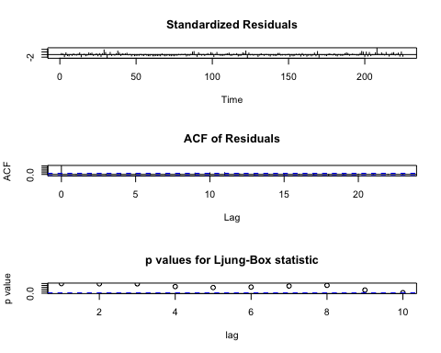

xlag1=lag(x1,1)  
xlag2=lag(x1,2)  
y=cbind(x1, xlag1, xlag2)  
set.seed(0)  
linear_fit=lm(y[,1]~y[,2]+y[,3])  
summary(linear_fit)

##   
## Call:  
## lm(formula = y[, 1] ~ y[, 2] + y[, 3])  
##   
## Residuals:  
## Min 1Q Median 3Q Max   
## -680.79 -123.59 -12.79 108.27 625.21   
##   
## Coefficients:  
## Estimate Std. Error t value Pr(>|t|)   
## (Intercept) 181.96952 22.33018 8.149 2.75e-14 ***  
## y[, 2] 1.37214 0.04929 27.837 < 2e-16 ***  
## y[, 3] -0.67812 0.04936 -13.738 < 2e-16 ***  
## ---  
## Signif. codes: 0 '***' 0.001 '**' 0.01 '*' 0.05 '.' 0.1 ' ' 1  
##   
## Residual standard error: 200.8 on 220 degrees of freedom  
## (4 observations deleted due to missingness)  
## Multiple R-squared: 0.8223, Adjusted R-squared: 0.8207   
## F-statistic: 509 on 2 and 220 DF, p-value: < 2.2e-16

plot(linear_fit$fit, linear_fit$residuals)

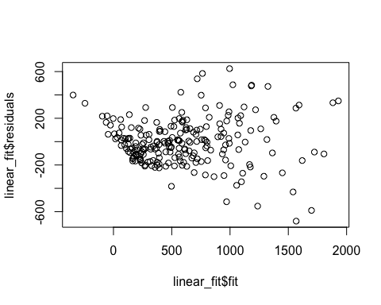

autoplot(forecast(fit1))

